Task on VPC

- Create VPC with 2 private and 2 public subnets.
- Enable DNS Hostname in VPC.
- Enable Auto Assign Public IP in 2 public subnets.
- Add 2 private subnets in private route table.
- Add 2 public subnets in public route table.
- Public route table will have the routes to internet and local.
- Create EC2 in public subnet with t2.micro and install PHP.
- Configure NAT gateway in public subnet and connect to private instance.
- Install Apache Tomcat in private EC2 and deploy a sample app.
- Configure VPC flow logs and store the logs in S3 and CloudWatch.

1: Create VPC with 2 private and 2 public subnets:
Step 1: Create VPC
- Go to AWS Console → VPC.
- Click Create VPC.
- Select VPC and more.
- Enter:
  - Name: Task-VPC-vpc
  - IPv4 CIDR: 10.0.0.0/16
- Configure:
  - Number of Availability Zones: 2
  - Number of public subnets: 2
  - Number of private subnets: 2
  - NAT Gateway: 1 per AZ or as required by your task.
- Keep the remaining settings as default unless your task specifies otherwise.
- Click Create VPC.
Step 2: Verify the VPC
Go to VPC → Your VPCs and verify:
- VPC Name: Task-VPC-vpc
- IPv4 CIDR: 10.0.0.0/16
- State: Available
Step 3: Verify the 4 Subnets
Go to VPC → Subnets.
You should have:
Subnet | Availability Zone | Type
Task-VPC-subnet-public1-us-east-1a | us-east-1a | Public
Task-VPC-subnet-public2-us-east-1b | us-east-1b | Public
Task-VPC-subnet-private1-us-east-1a | us-east-1a | Private
Task-VPC-subnet-private2-us-east-1b | us-east-1b | Private
Step 4: Verify Route Tables
Go to VPC → Route Tables.
You should have:
- Task-VPC-rtb-public
- Task-VPC-rtb-private1-us-east-1a
- Task-VPC-rtb-private2-us-east-1b
The public route table should have:
0.0.0.0/0 → Internet Gateway
The private route tables should use the NAT Gateway for outbound internet access.
Step 5: Verify Network Connections
Check that you have:
- Internet Gateway: Task-VPC-igw ✅
- NAT Gateway: Task-VPC-nat-public1-us-east-1a ✅
- S3 VPC Endpoint: Task-VPC-vpce-s3 ✅
Final verification
Your architecture should look like:
Task-VPC-vpc
10.0.0.0/16
│
├── Public Subnet 1 ── us-east-1a
│ └── Internet Gateway
│
├── Public Subnet 2 ── us-east-1b
│ └── Internet Gateway
│
├── Private Subnet 1 ── us-east-1a
│ └── NAT Gateway
│
└── Private Subnet 2 ── us-east-1b
└── NAT Gateway
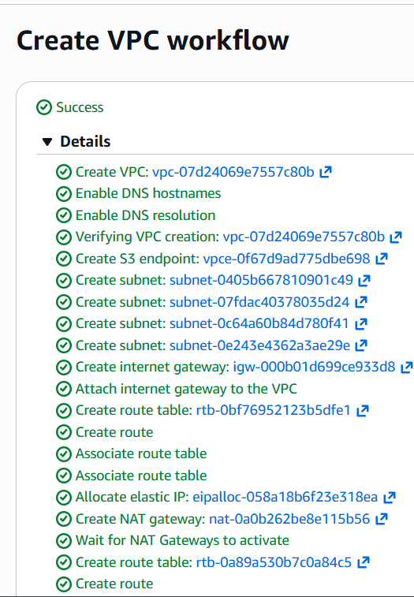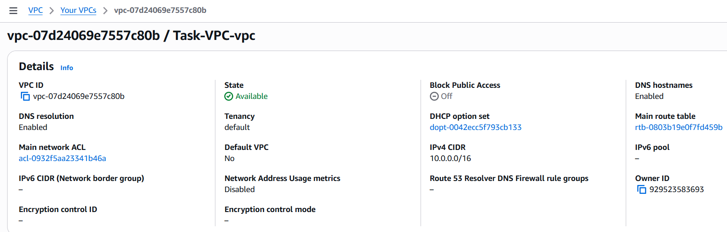
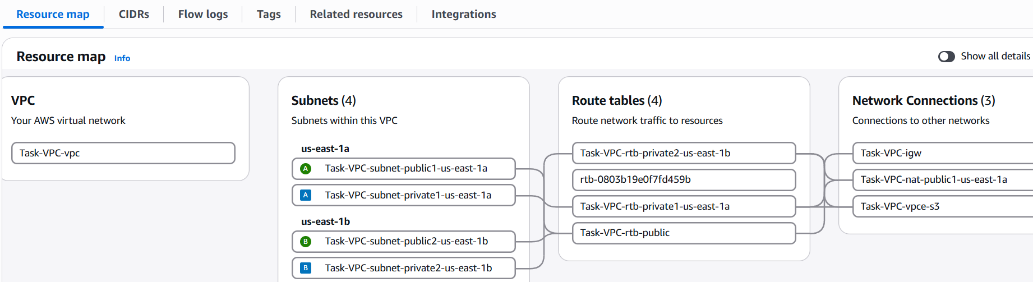

2: Enable DNS Hostname in VPC.
Enable DNS Hostnames
- Go to VPC → Your VPCs.
- Select Task-VPC-vpc.
- Go to Actions → Edit VPC settings.
- Under DNS settings, enable:
  - ✅ DNS hostnames
  - ✅ DNS resolution
- Click Save.
Verify: VPC details should show DNS hostnames: Enabled ✅

3: Enable Auto Assign Public IP in 2 public subnets.
- Go to VPC → Subnets.
- Select Public Subnet 1.
- Actions → Edit subnet settings.
- Enable ✅ Auto-assign public IPv4 address.
- Click Save.
- Repeat for Public Subnet 2.
Verify: Both public subnets show Auto-assign public IPv4: On ✅
Status: Completed when both are On.
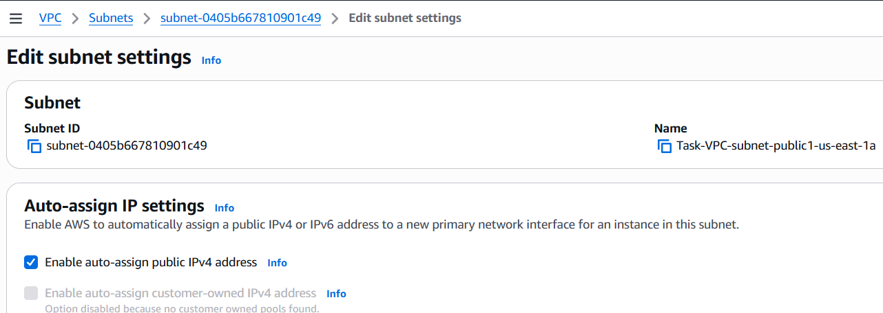
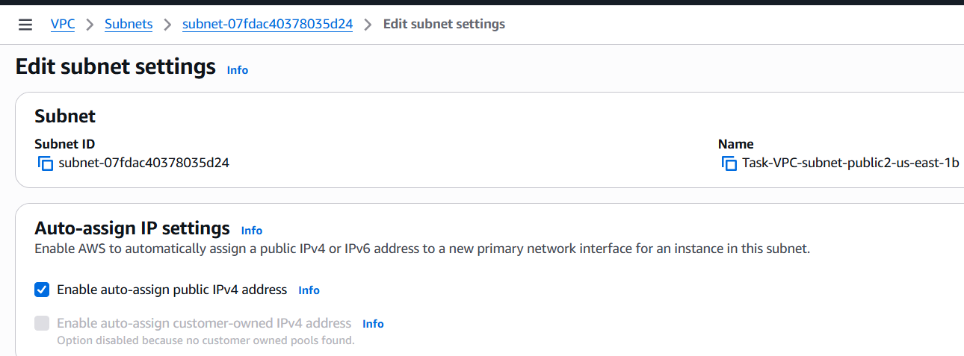

4: Add 2 private subnets in private route table.
- Go to VPC → Route Tables.
- Select Task-VPC-rtb-private1-us-east-1a.
- Go to Subnet associations → Edit subnet associations.
- Select Task-VPC-subnet-private1-us-east-1a.
- Click Save associations.
- Select Task-VPC-rtb-private2-us-east-1b.
- Go to Subnet associations → Edit subnet associations.
- Select Task-VPC-subnet-private2-us-east-1b.
- Click Save associations.
Private Subnet 1 → Task-VPC-rtb-private1-us-east-1a → ✅ Successfully updated
Private Subnet 2 → Task-VPC-rtb-private2-us-east-1b → ✅ Already associated
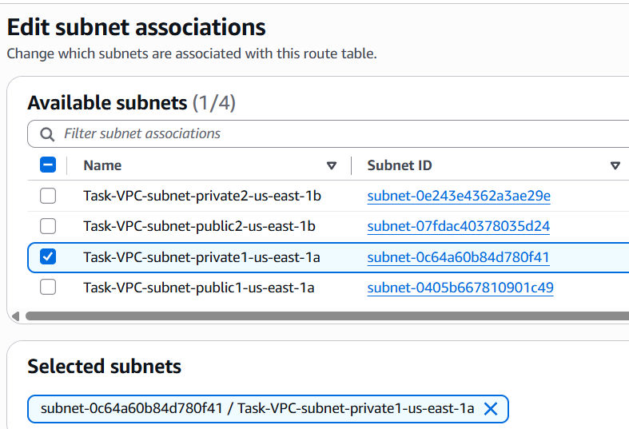

5: Add 2 public subnets in public route table.
- Go to VPC → Route Tables.
- Select Task-VPC-rtb-public.
- Go to Subnet associations.
- Click Edit subnet associations.
- Select:
  - Task-VPC-subnet-public1-us-east-1a
  - Task-VPC-subnet-public2-us-east-1b
- Click Save associations.
Verify
- Public Subnet 1 → Task-VPC-rtb-public ✅
- Public Subnet 2 → Task-VPC-rtb-public ✅
- Route table shows 2 subnets ✅

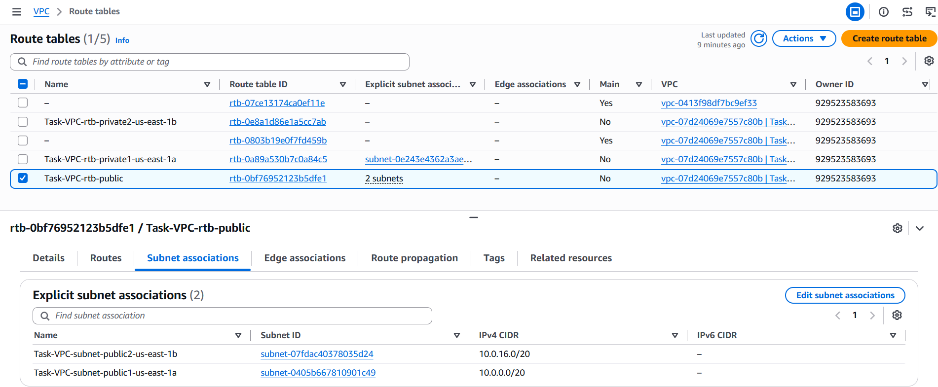

6: Public route table will have the routes to internet and local.
• Go to VPC → Route Tables.
• Select Task-VPC-rtb-public.
• Open the Routes tab.
• Click Edit routes.
• Verify these routes:
- 10.0.0.0/16 → local ✅
- 0.0.0.0/0 → igw-000b01d699ce933d8 ✅
• If both routes already exist, no changes are required.
Click Cancel if AWS says "You have not made any changes."

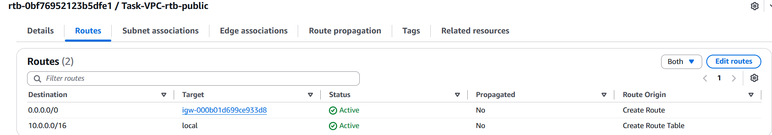
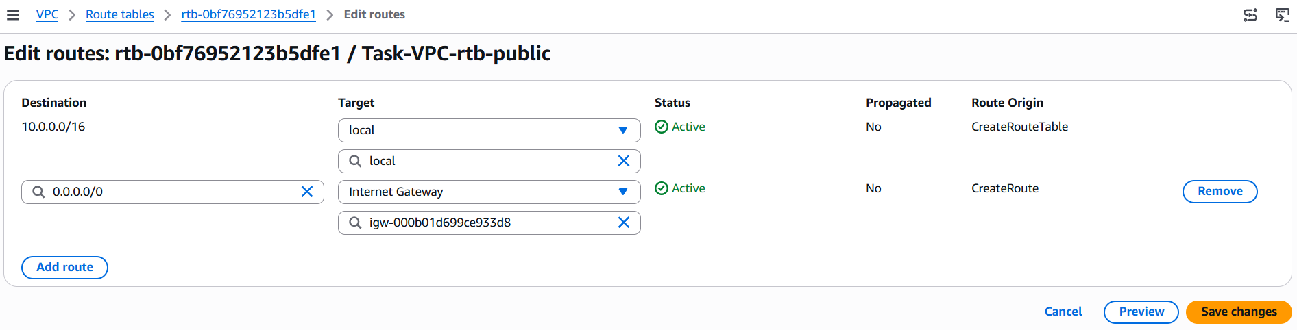
7: Create EC2 in public subnet with t2.micro and install PHP.
- Go to AWS Console → EC2 → Instances.
- Click Launch instance.
- Name: Task7-PHP
- AMI: Choose Amazon Linux 2 (if your task doesn't specify another OS).
- Instance type: t2.micro.
- Key pair: Select your existing key pair.
- Under Network settings → Edit:
  - VPC: Task-VPC-vpc
  - Subnet: Task-VPC-subnet-public1-us-east-1a
  - Auto-assign Public IP: Enable
- Create/select a security group.
- Allow:
  - SSH (22) → My IP
  - HTTP (80) → 0.0.0.0/0
- Under Advanced details → User data, enter the PHP installation script.
- Click Launch instance.
User Data for PHP
For Amazon Linux 2:
#!/bin/bash
yum update -y
amazon-linux-extras enable php8.0
yum clean metadata
yum install -y php
Step 2: Verify
After the instance starts, connect to it through SSH and run:
Command: php -v
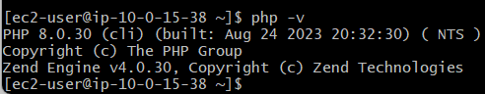
Status
- EC2 in public subnet ✅
- Instance type t2.micro ✅
- Public IP enabled ✅
- PHP installed ✅
8: Configure NAT gateway in public subnet and connect to private instance.
- NAT Gateway in public subnet → ✅
- NAT Gateway is Available → ✅
- Private route table uses NAT Gateway → ✅
- Private EC2 created → ✅
- Private EC2 has no public IP → ✅
- Connected from public EC2 to private EC2 → ✅
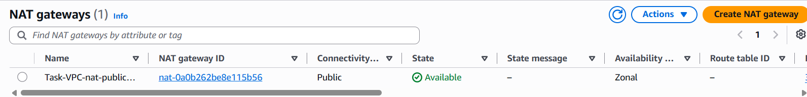
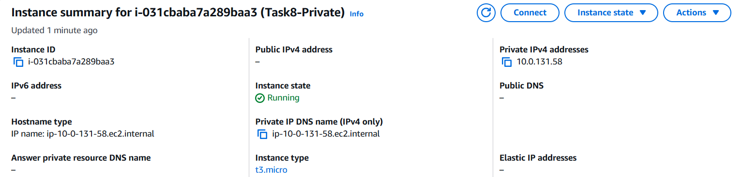
successfully connected:
Windows PC
↓ SSH
Public EC2
10.0.15.38
↓ SSH
Private EC2
10.0.131.58
Your prompt:
[ec2-user@ip-10-0-131-58 ~]$

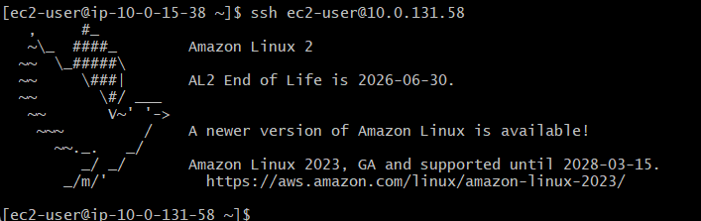

9: Install Apache Tomcat in private EC2 and deploy a sample app.
Error SS: 404 NOT FOUND DUE TO OLD VERSION INSTALL
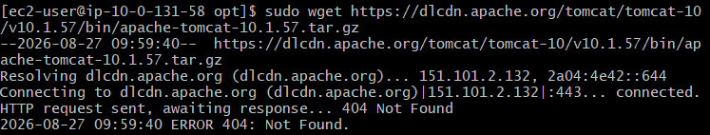
Used this: sudo wget https://dlcdn.apache.org/tomcat/tomcat-10/v10.1.59/bin/apache-tomcat-10.1.59.tar.gz
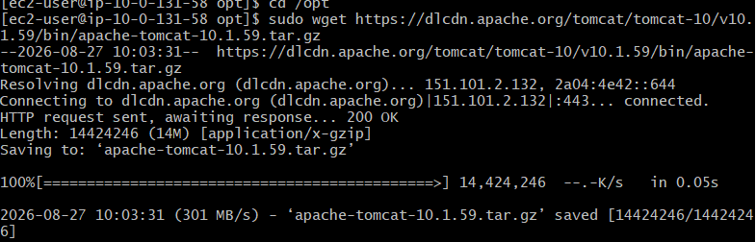
sudo mkdir -p /opt/tomcat/webapps/sampleapp
sudo vi /opt/tomcat/webapps/sampleapp/index.html
Add:
<html>
<head>
<title>Task 9</title>
</head>
<body>
<h1>Hello from Private EC2 Tomcat!</h1>
</body>
</html>
And Save :wq!
curl http://localhost:8080/sampleapp/
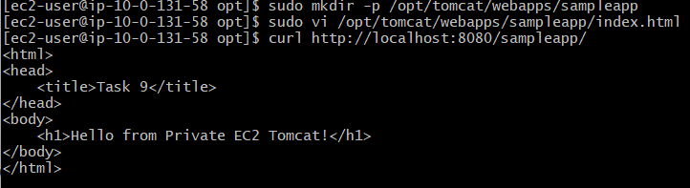
10: Configure VPC flow logs and store the logs in S3 and CloudWatch.
Part 1: Flow Logs → S3
- VPC → Your VPCs → Task-VPC-vpc
- Actions → Create flow log
- Name: Task-VPC-FlowLog-S3
- Filter: All
- Aggregation: 10 minutes
- Destination: Send to an Amazon S3 bucket
- Create/select S3 bucket.
- Enter S3 ARN:
arn:aws:s3:::task-vpc-flow-logs-929523583693
- Create flow log ✅
Part 2: Flow Logs → CloudWatch
- VPC → Task-VPC-vpc → Flow logs → Create flow log
- Name: Task-VPC-FlowLog-CloudWatch
- Filter: All
- Aggregation: 10 minutes
- Destination: Send to CloudWatch Logs
- Log group:
/aws/vpc/Task-VPC-flow-logs
- Service access: Create and use a new service role
- Select the created role:
VPCFlowLogs-Cloudwatch-1787826573332
- Create flow log ✅
Final check
Both should show State: Active:
Task-VPC-FlowLog-S3 → S3 ✅
Task-VPC-FlowLog-CloudWatch → CloudWatch ✅
- VPC Flow Logs
↓
┌───┴────────┐
↓ ↓
S3 CloudWatch
Storage Monitoring/Logs

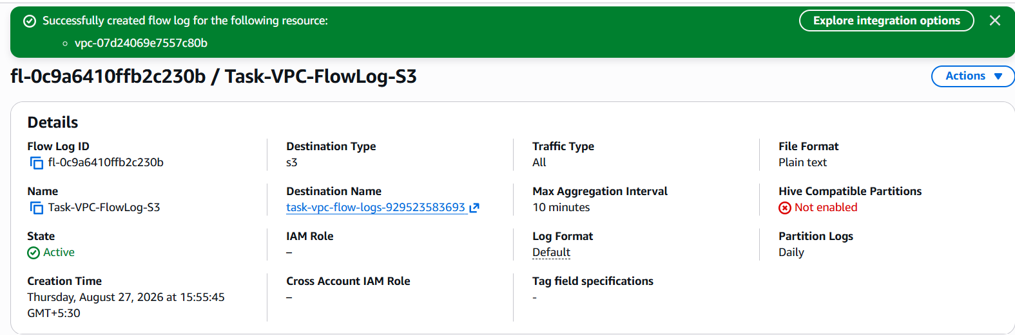
S3 Flow Log is successfully created.
